**DBFUND – Final Project: Designing and Implementing a Database**

**Tutor Were Vincent**

**DBFUND – Final Project: Designing and Implementing a Database**

1. **Diagram representing the tables and their relationships**
2. **Diagram**

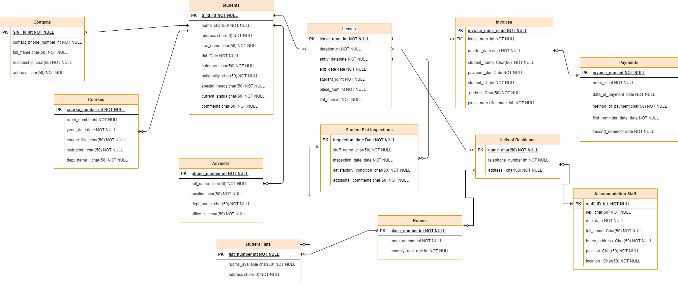

1. **Relationships**
2. ***Students and Leases***

One-to-Many: A student can have multiple leases over time, but each lease belongs to one student.

1. ***Students and Advisors***

One-to-Many: Each student has one advisor, but an advisor may advise multiple students.

1. ***Students and Courses***

Many-to-Many: A student can be registered for multiple courses, and a course can have multiple students.

1. ***Students and Contacts***

One-to-Many: Each student can have multiple contacts, but each contact is associated with one student.

1. ***Leases and Invoices***

One-to-Many: Each lease can have multiple invoices, but each invoice is related to one lease.

1. ***Leases and Student Flat Inspections***

One-to-Many: Each lease can have multiple inspections, but each inspection is related to one lease.

1. ***Leases and Student Flats (or Halls of Residence)***

Many-to-One: Each lease is associated with one student flat or hall, but multiple leases can be associated with the same flat or hall.

1. ***Invoices and Payments***

One-to-Many: Each invoice can have multiple payments, but each payment is associated with one invoice.

1. ***Advisors and Students***

One-to-Many: Each advisor advises multiple students, but each student has only one advisor.

1. ***Halls of Residence and Rooms***

One-to-Many: Each hall has multiple rooms, but each room belongs to one hall.

1. ***Student Flats and Rooms***

One-to-Many: Each student flat has multiple rooms, but each room belongs to one student flat.

1. ***Student Flat Inspections and Student Flats***

One-to-Many: Each inspection is related to one student flat, but a student flat may have multiple inspections over time.

1. ***Accommodation Staff and Halls of Residence***

One-to-Many: Each staff member is associated with one hall, but each hall has multiple staff members.

1. ***Courses and Students***

Many-to-Many: A course can have multiple students, and a student can be enrolled in multiple courses.

1. ***Contacts and Students***

One-to-Many: Each contact is associated with one student, but each student can have multiple contacts.

These relationships help define how the different entities in the database are connected and how data flows between them. It's essential to maintain referential integrity and ensure that the relationships reflect the real-world connections between the entities accurately.

1. **Tables in Microsoft SQL Server 2019 (GUI or commands)**

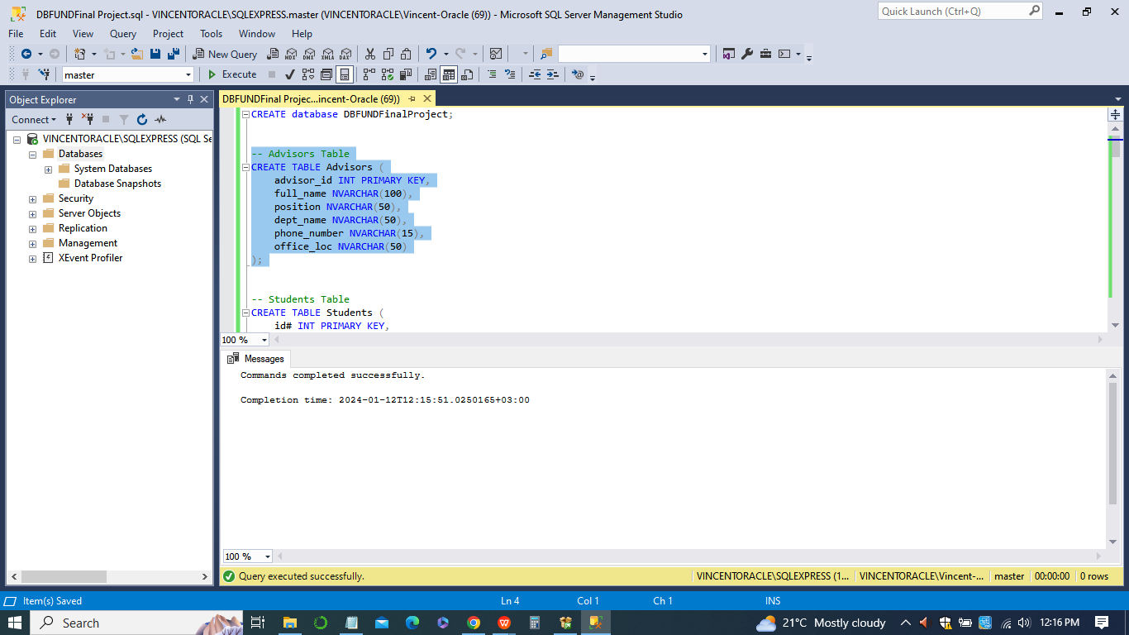

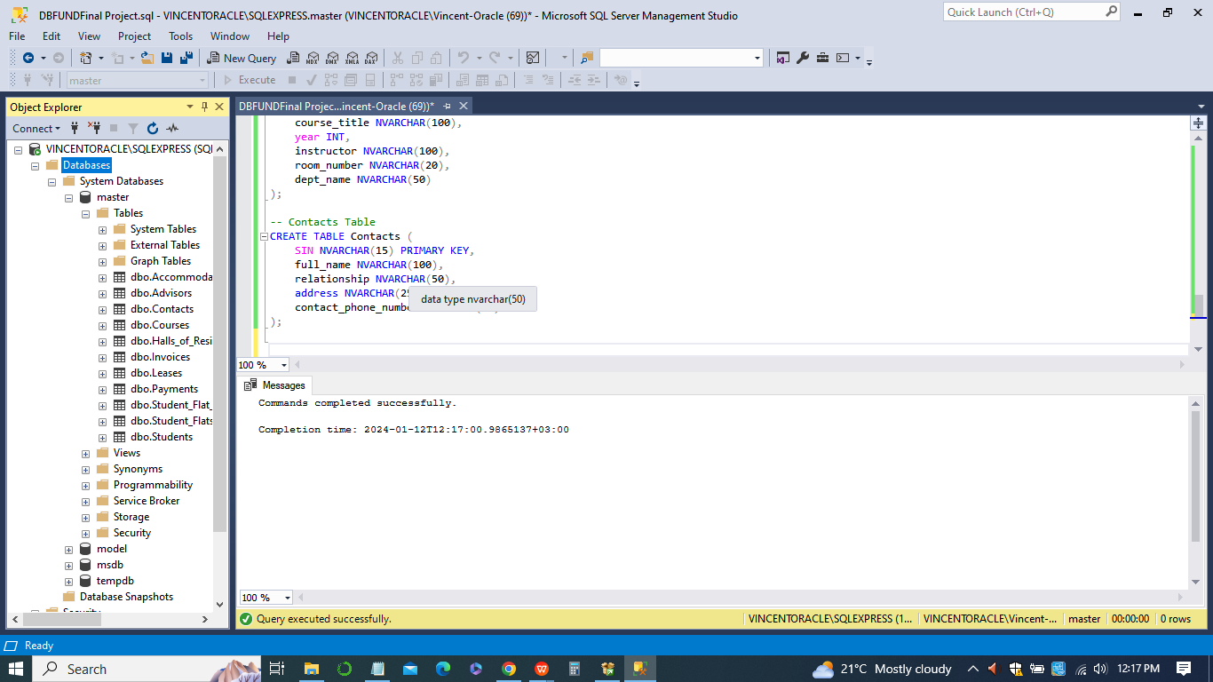

1. **Sample records within each table**

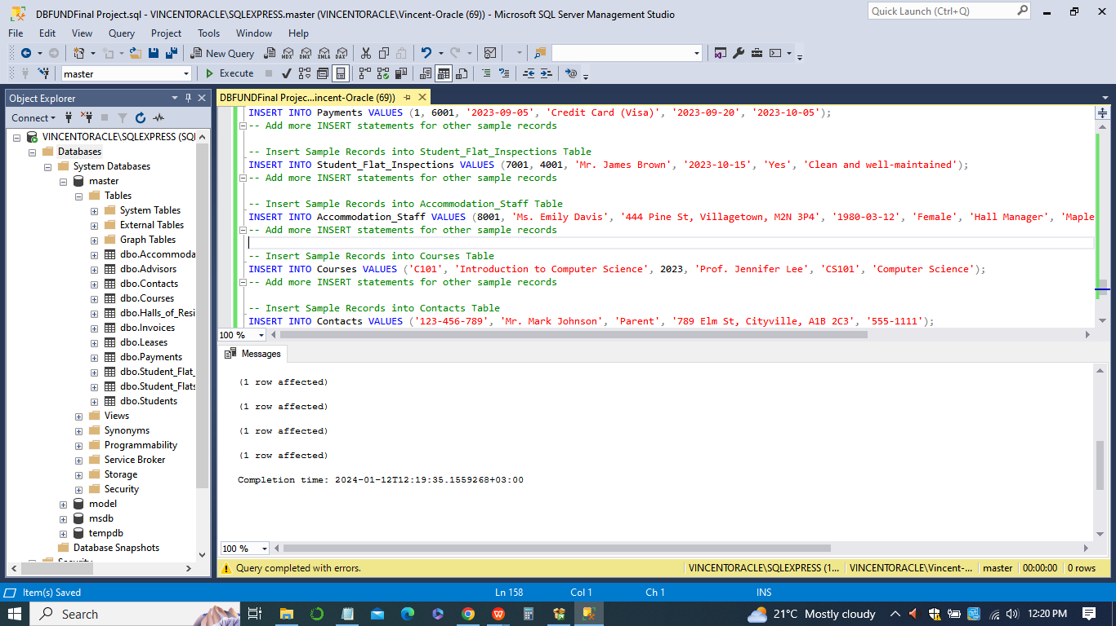

*-- Insert Sample Records into Students Table*

*INSERT INTO Students VALUES (1001, 'John Doe', '123 Main St, Cityville, A1B 2C3', '1995-05-15', 'Male', 'Sophomore', 'Canadian', NULL, 'Placed', 'Excellent student', 2001);*

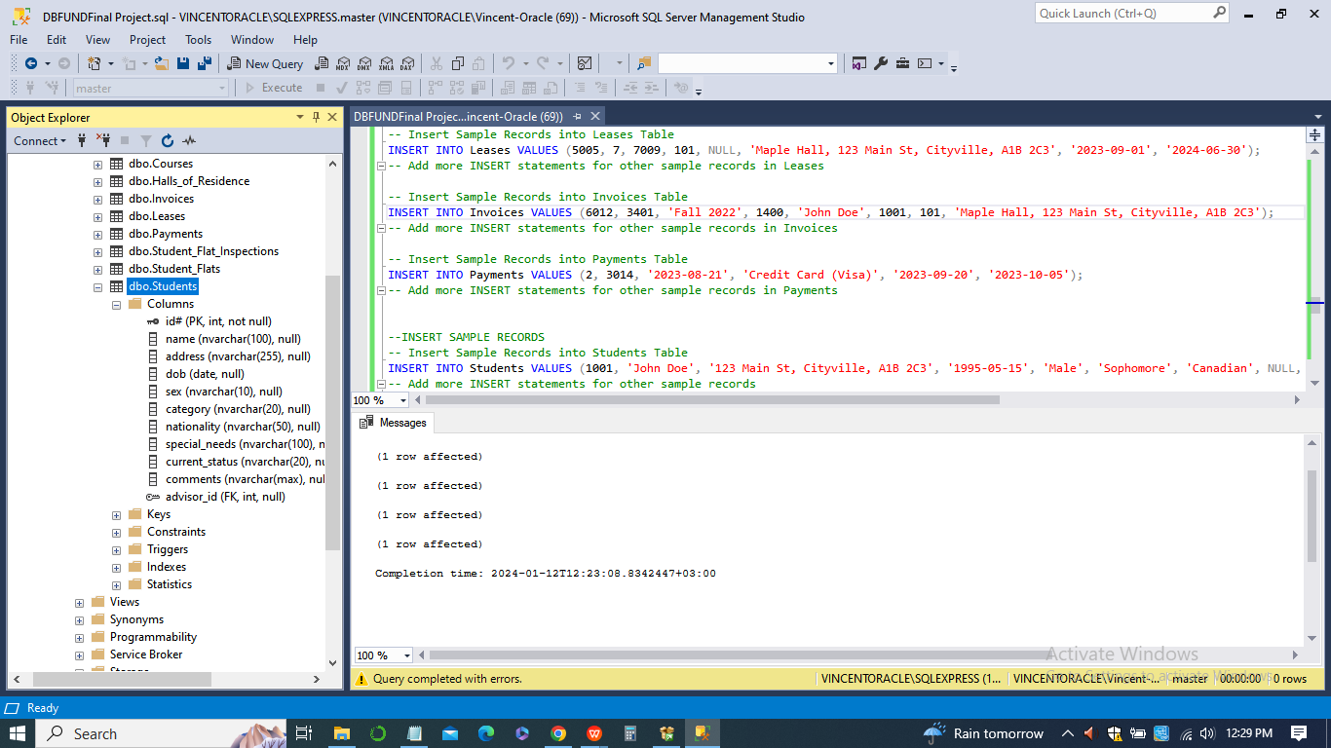

*-- Insert Sample Records into Advisors Table*

*INSERT INTO Advisors VALUES (2001, 'Dr. Alice Johnson', 'Academic Advisor', 'Computer Science', '555-1234', 'CS Building, Room 101');*

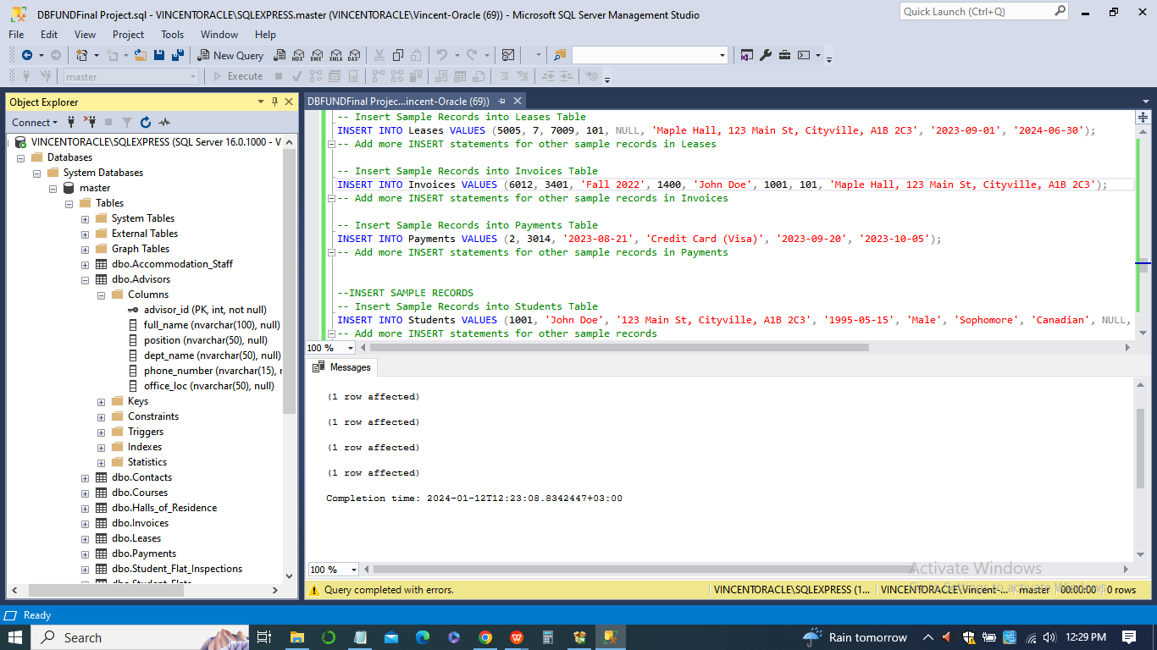

*-- Insert Sample Records into Halls_of_Residence Table*

*INSERT INTO Halls_of_Residence VALUES (3001, 'Maple Hall', '789 Pine St, Villagetown, M2N 3P4', '555-9876', 'Mr. James Brown');*

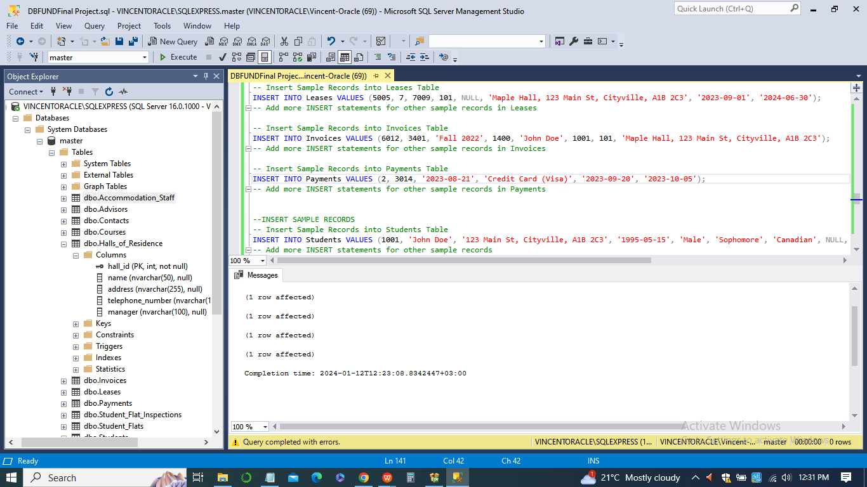

*-- Insert Sample Records into Student_Flats Table*

*INSERT INTO Student_Flats VALUES (4001, 'F101', '111 Elm St, Cityville, A1B 2C3', 3);*

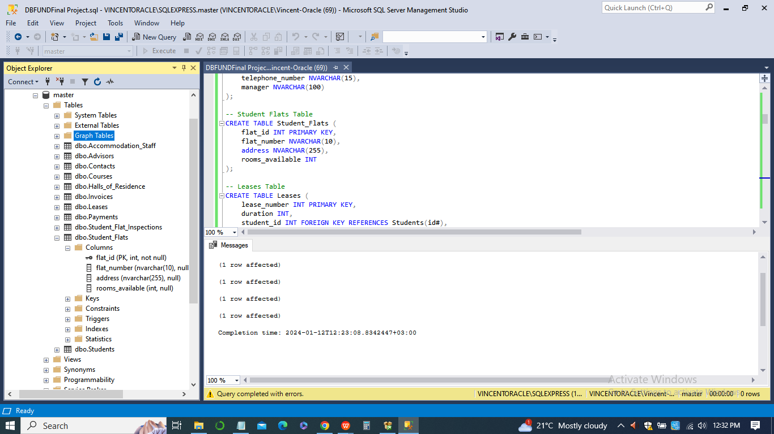

*-- Insert Sample Records into Leases Table*

*INSERT INTO Leases VALUES (5001, 2, 1001, 101, NULL, 'Maple Hall, 123 Main St, Cityville, A1B 2C3', '2023-09-01', '2024-06-30');*

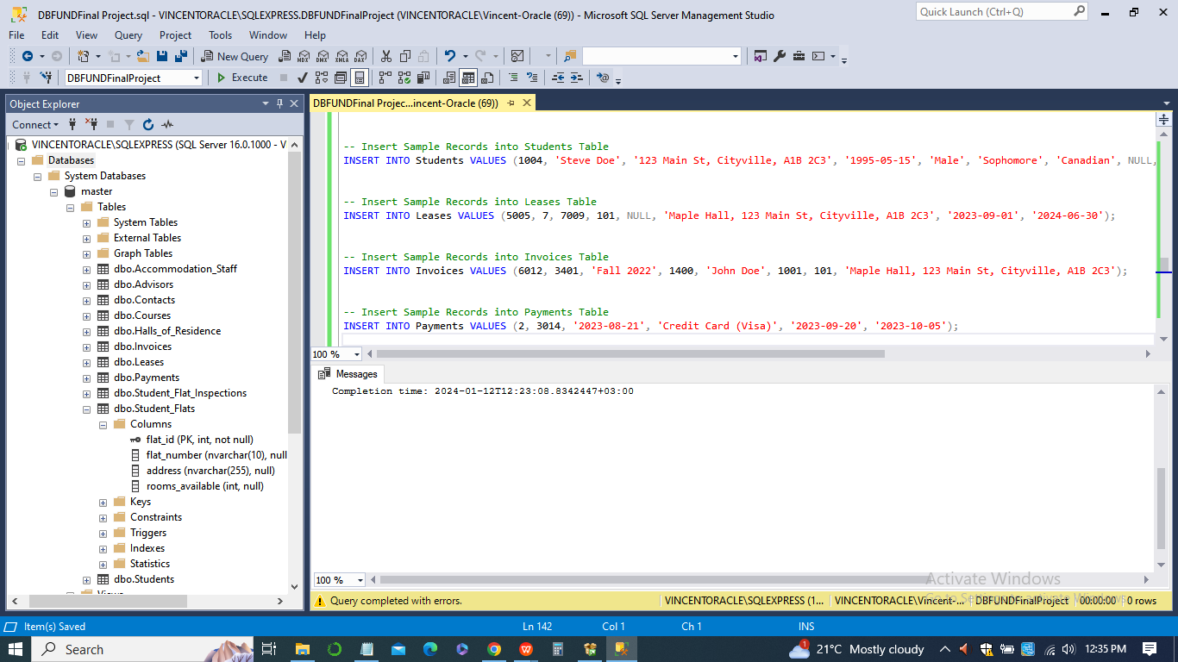

*-- Insert Sample Records into Invoices Table*

*INSERT INTO Invoices VALUES (6001, 5001, 'Fall 2023', 1200, 'John Doe', 1001, 101, 'Maple Hall, 123 Main St, Cityville, A1B 2C3');*

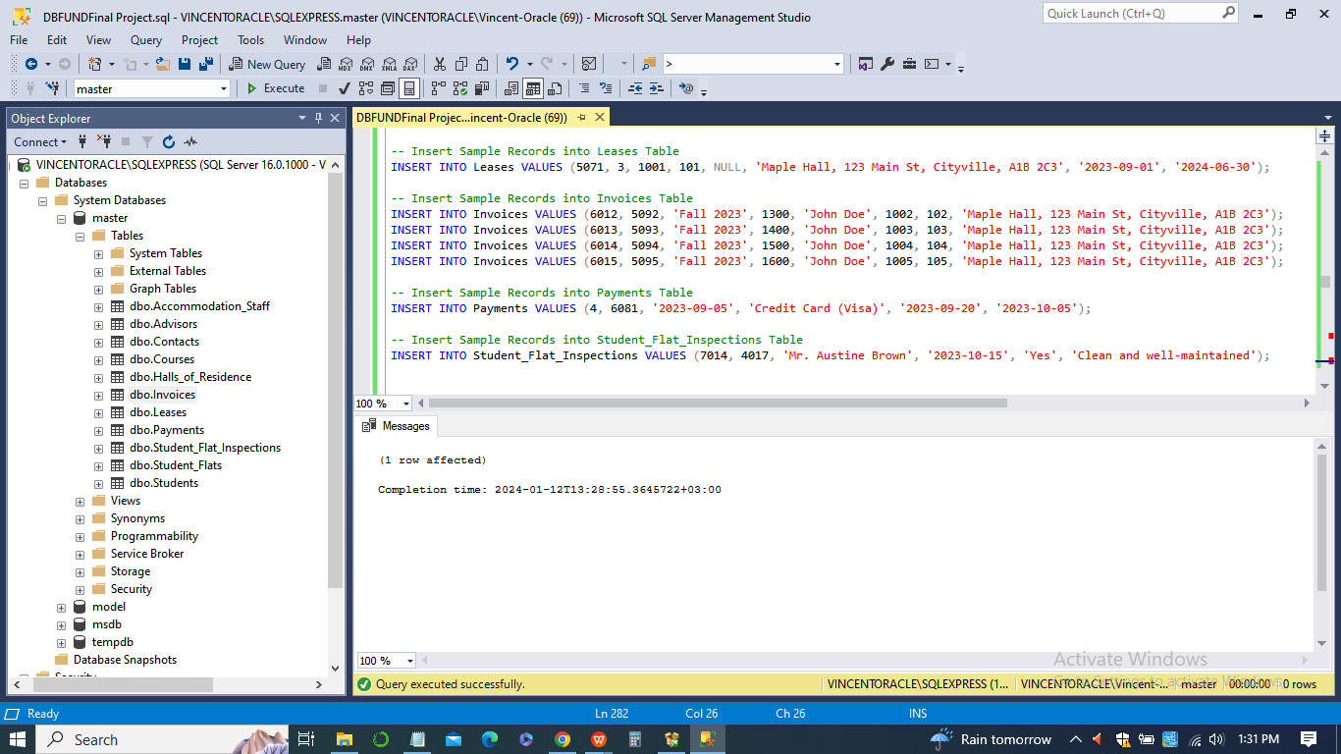

*-- Insert Sample Records into Payments Table*

*INSERT INTO Payments VALUES (1, 6001, '2023-09-05', 'Credit Card (Visa)', '2023-09-20', '2023-10-05');*

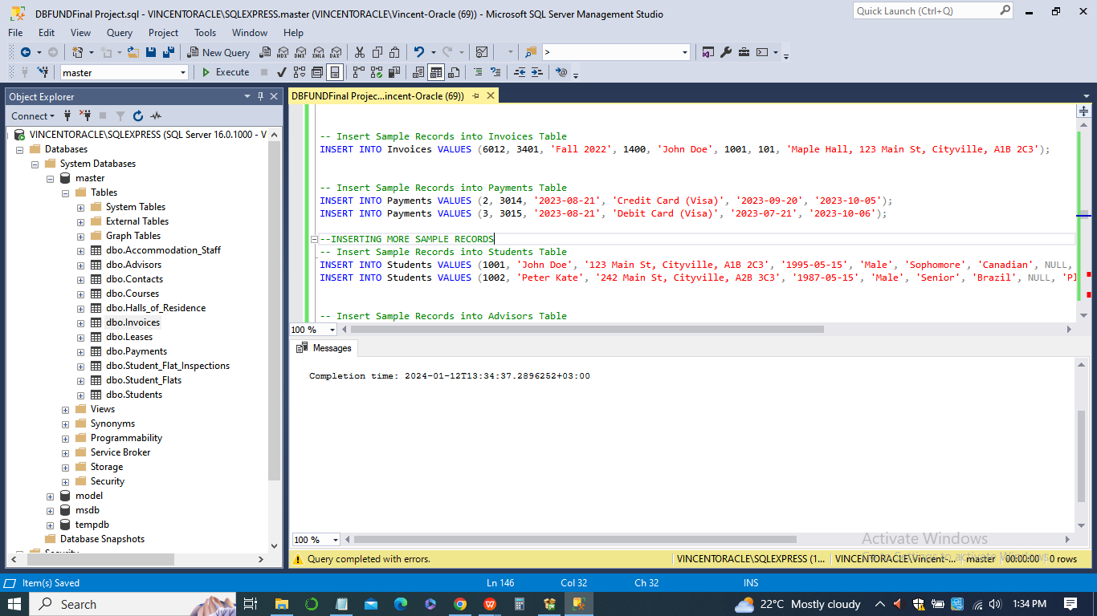

*-- Insert Sample Records into Student_Flat_Inspections Table*

*INSERT INTO Student_Flat_Inspections VALUES (7001, 4001, 'Mr. James Brown', '2023-10-15', 'Yes', 'Clean and well-maintained');*

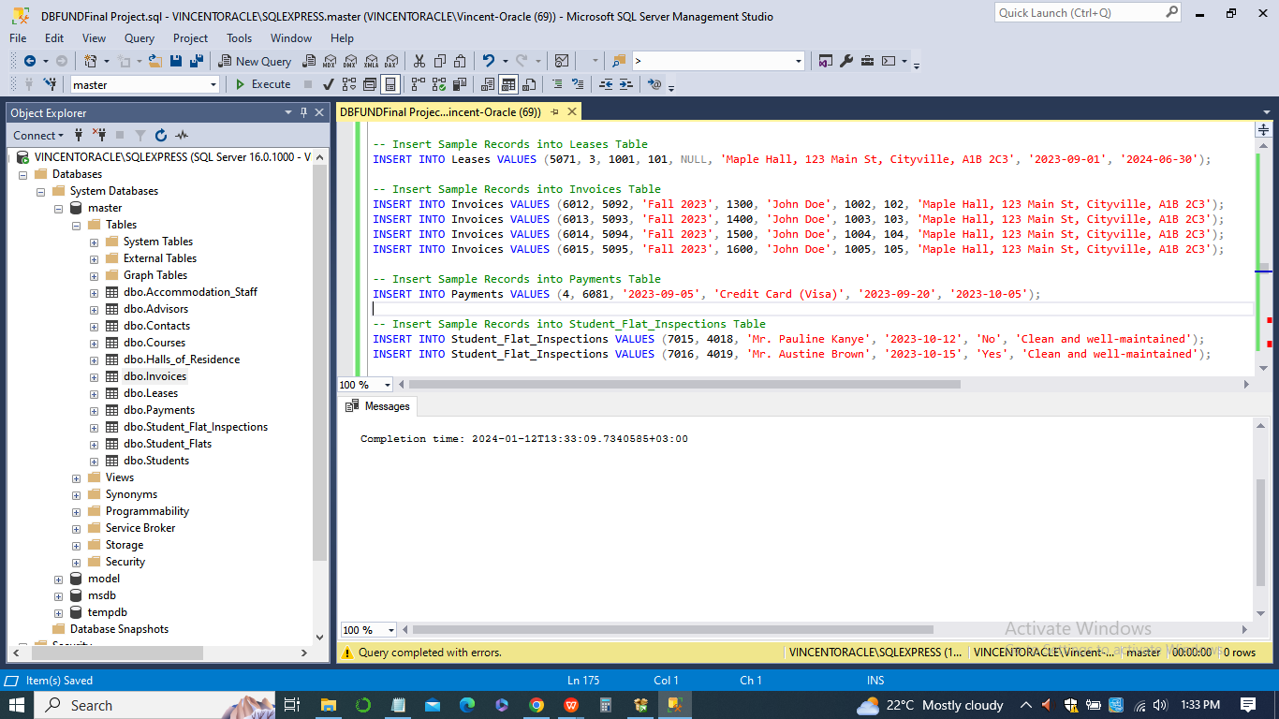

*-- Insert Sample Records into Accommodation_Staff Table*

*INSERT INTO Accommodation_Staff VALUES (8001, 'Ms. Emily Davis', '444 Pine St, Villagetown, M2N 3P4', '1980-03-12', 'Female', 'Hall Manager', 'Maple Hall');*

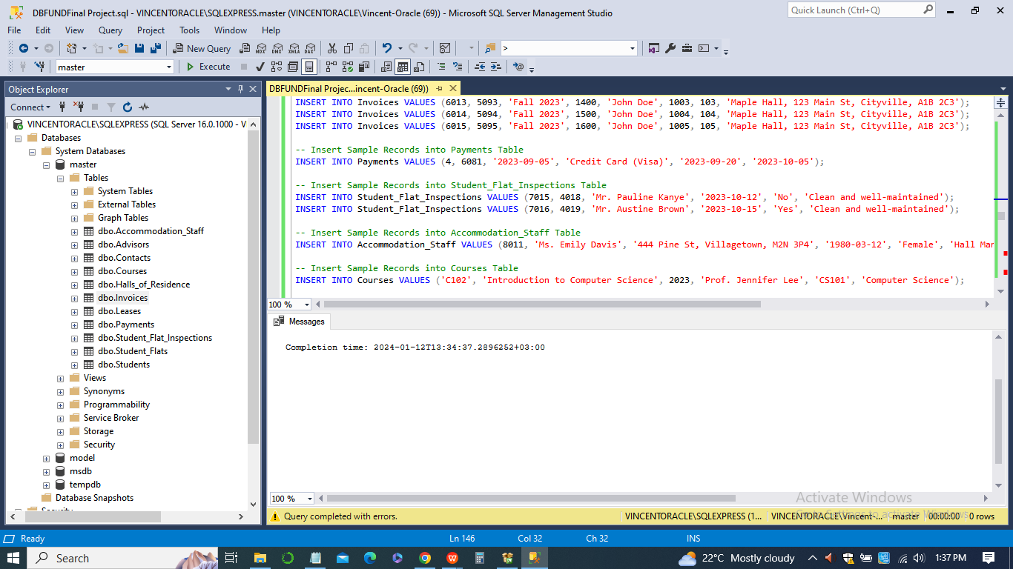

*-- Insert Sample Records into Courses Table*

*INSERT INTO Courses VALUES ('C101', 'Introduction to Computer Science', 2023, 'Prof. Jennifer Lee', 'CS101', 'Computer Science');*

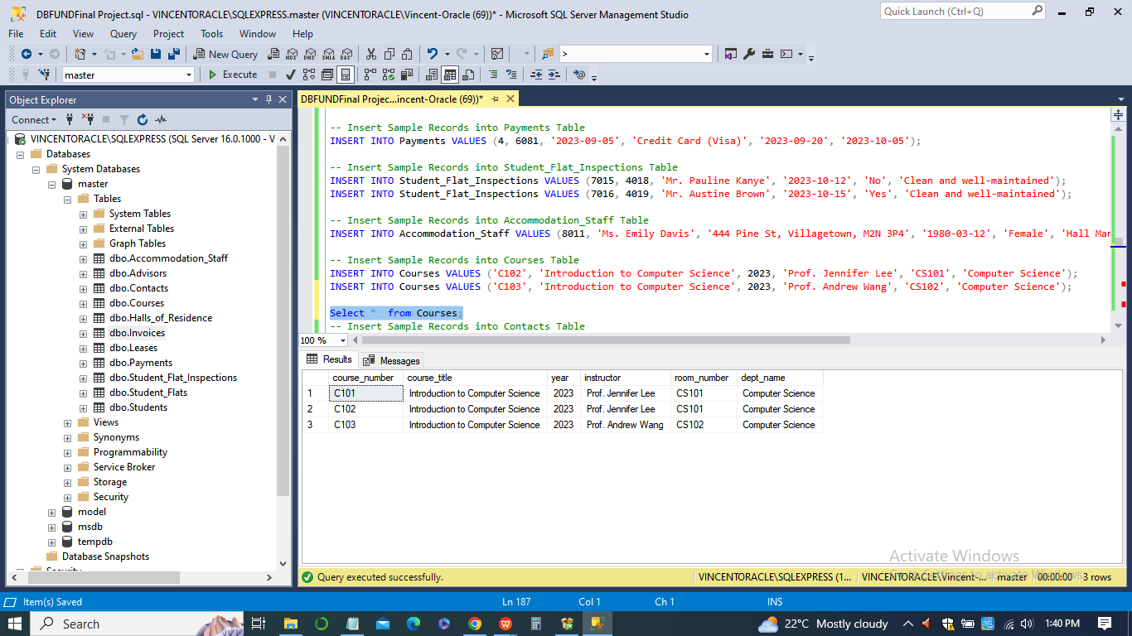

*-- Insert Sample Records into Contacts Table*

*INSERT INTO Contacts VALUES ('123-456-789', 'Mr. Mark Johnson', 'Parent', '789 Elm St, Cityville, A1B 2C3', '555-1111');*

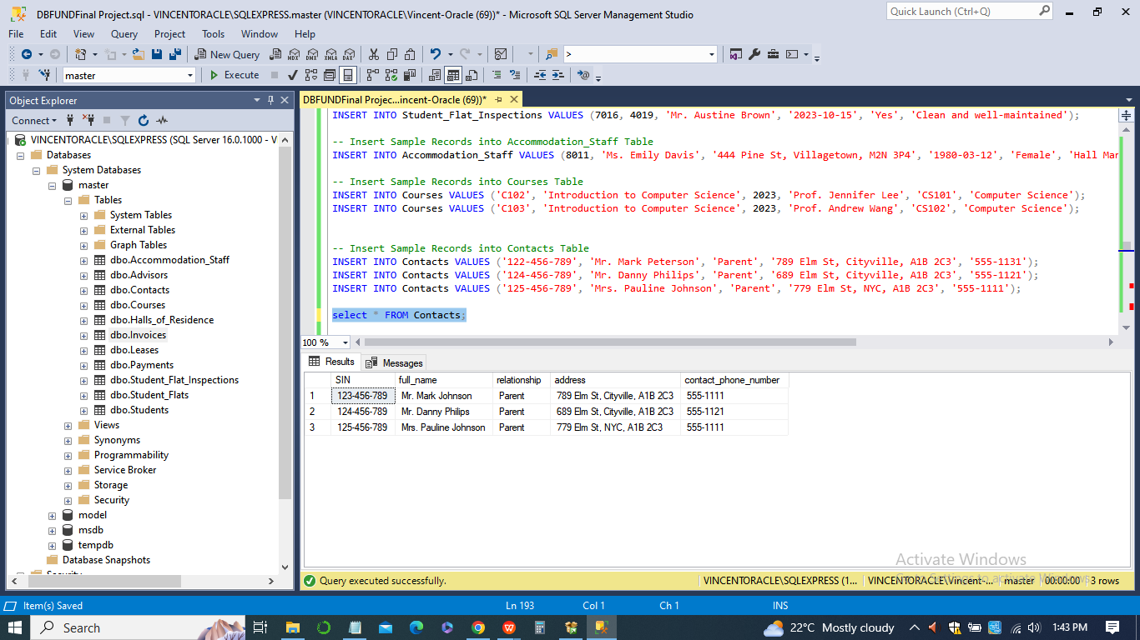

1. **Create the appropriate indexes on each table**

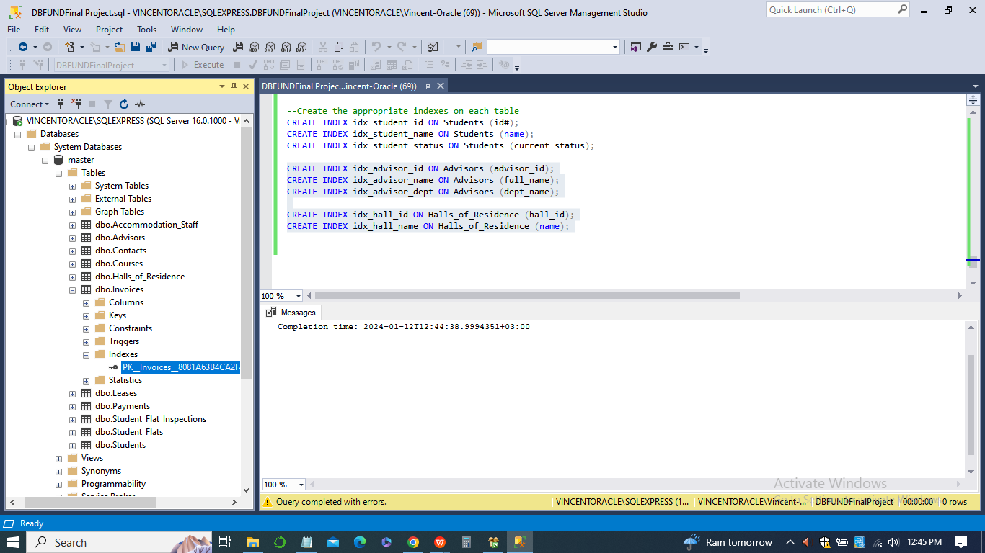

1. ***Students Table***

*CREATE INDEX idx_student_id ON Students (id#);*

*CREATE INDEX idx_student_name ON Students (name);*

*CREATE INDEX idx_student_status ON Students (current_status);*

1. ***Advisors Table***

*CREATE INDEX idx_advisor_id ON Advisors (advisor_id);*

*CREATE INDEX idx_advisor_name ON Advisors (full_name);*

*CREATE INDEX idx_advisor_dept ON Advisors (dept_name);*

1. ***Halls of Residence Table***

*CREATE INDEX idx_hall_id ON Halls_of_Residence (hall_id);*

*CREATE INDEX idx_hall_name ON Halls_of_Residence (name);*

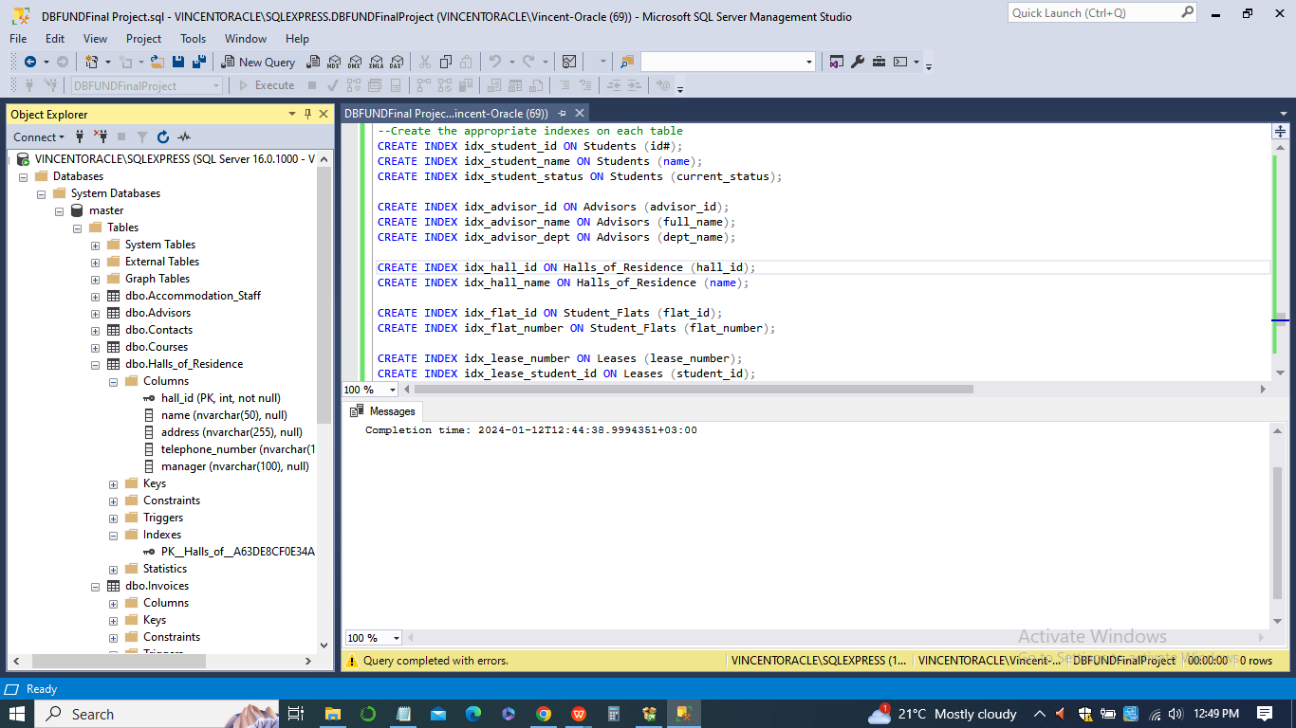

1. ***Student Flats Table***

*CREATE INDEX idx_flat_id ON Student_Flats (flat_id);*

*CREATE INDEX idx_flat_number ON Student_Flats (flat_number);*

1. ***Leases Table***

*CREATE INDEX idx_lease_number ON Leases (lease_number);*

*CREATE INDEX idx_lease_student_id ON Leases (student_id);*

1. ***Invoices Table***

*CREATE INDEX idx_invoice_number ON Invoices (invoice_number);*

*CREATE INDEX idx_invoice_student_id ON Invoices (student_id);*

1. ***Payments Table***

*CREATE INDEX idx_payment_invoice_number ON Payments (invoice_number);*

1. ***Student Flat Inspections Table***

*CREATE INDEX idx_inspection_id ON Student_Flat_Inspections (inspection_id);*

*CREATE INDEX idx_inspection_date ON Student_Flat_Inspections (inspection_date);*

1. ***Accommodation Staff Table***

*CREATE INDEX idx_staff_id ON Accommodation_Staff (staff_id);*

*CREATE INDEX idx_staff_name ON Accommodation_Staff (full_name);*

1. ***Courses Table***

*CREATE INDEX idx_course_number ON Courses (course_number);*

*CREATE INDEX idx_course_title ON Courses (course_title);*

1. ***Contacts Table***

*CREATE INDEX idx_contact_sin ON Contacts (SIN);*

*CREATE INDEX idx_contact_name ON Contacts (full_name);*

1. **Database Queries to create 5 different reports**
2. ***Report 1: List of Students and their Advisors***

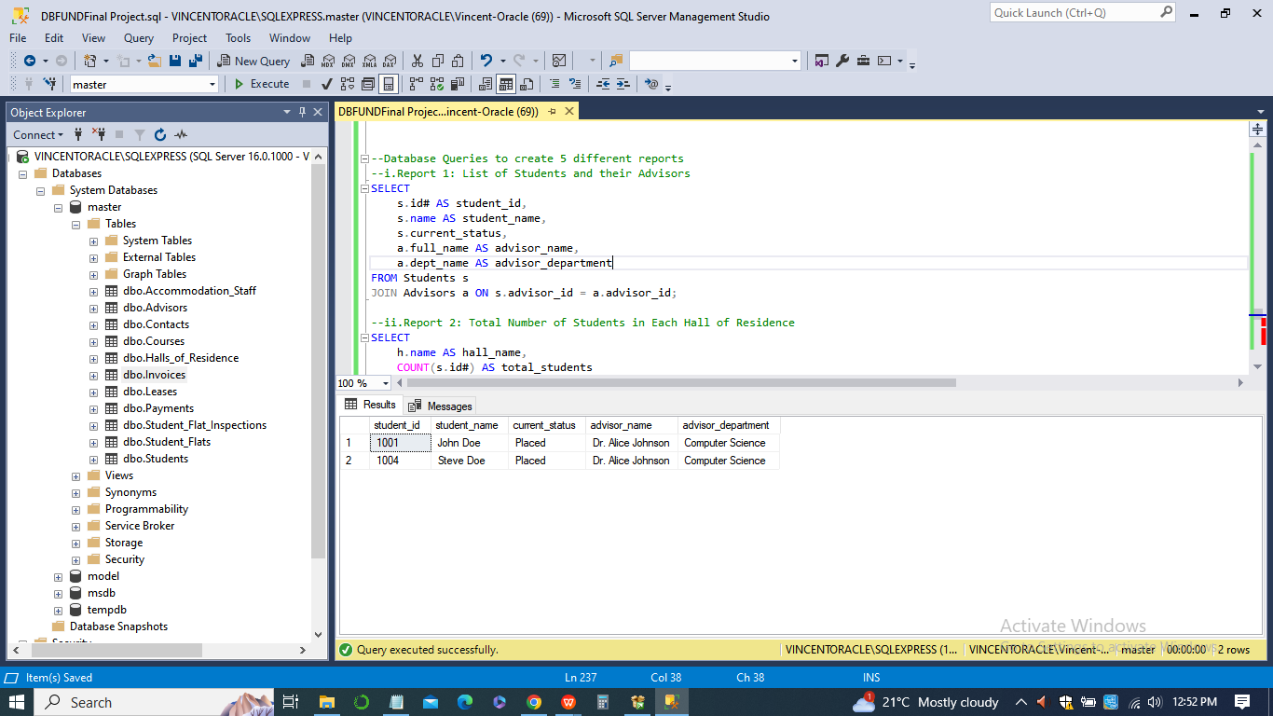

*SELECT*

*s.id# AS student_id,*

*s.name AS student_name,*

*s.current_status,*

*a.full_name AS advisor_name,*

*a.dept_name AS advisor_department*

*FROM Students s*

*JOIN Advisors a ON s.advisor_id = a.advisor_id;*

1. ***Report 2: Total Number of Students in Each Hall of Residence***

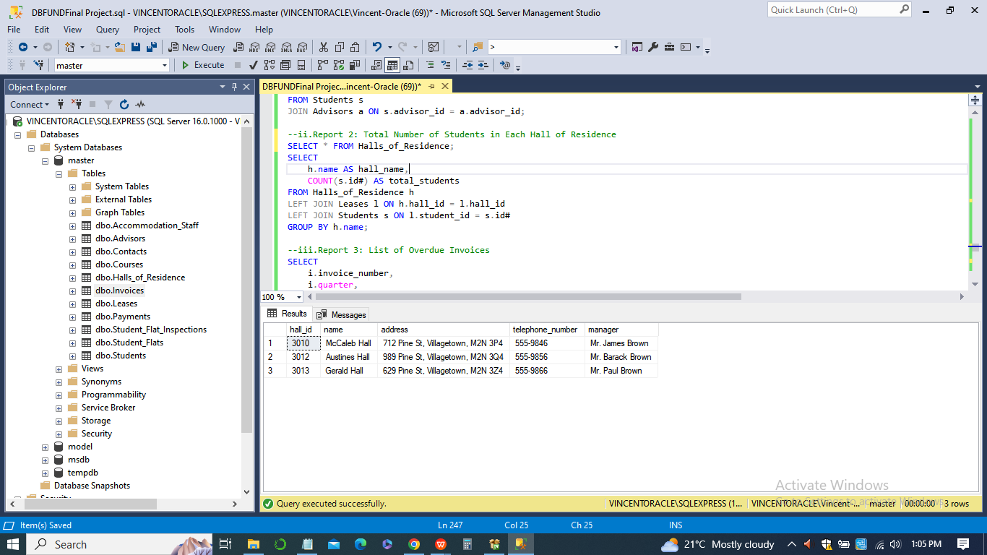

*SELECT*

*h.name AS hall_name,*

*COUNT(s.id#) AS total_students*

*FROM Halls_of_Residence h*

*LEFT JOIN Leases l ON h.hall_id = l.hall_id*

*LEFT JOIN Students s ON l.student_id = s.id#*

*GROUP BY h.name;*

1. ***Report 3: List of Overdue Invoices***

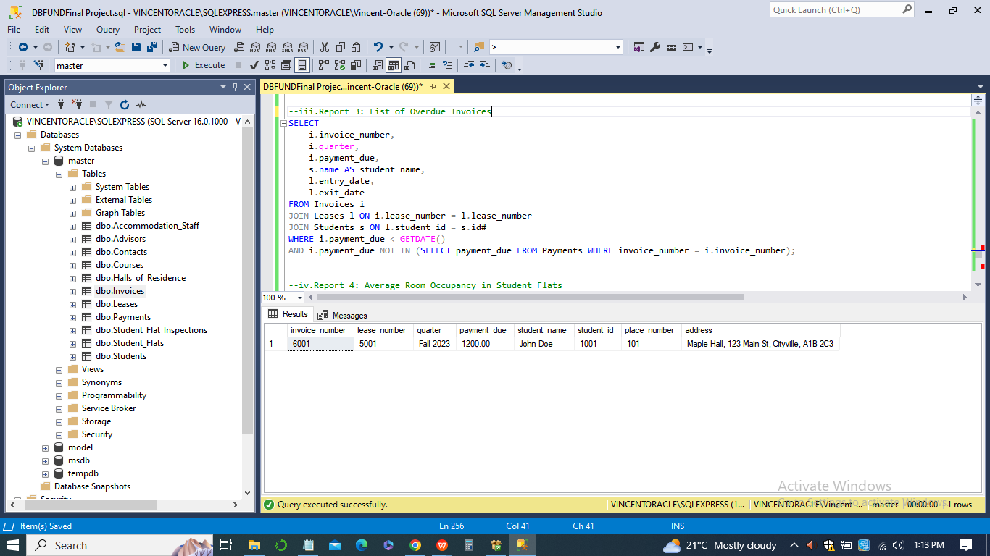

*SELECT*

*i.invoice_number,*

*i.quarter,*

*i.payment_due,*

*s.name AS student_name,*

*l.entry_date,*

*l.exit_date*

*FROM Invoices i*

*JOIN Leases l ON i.lease_number = l.lease_number*

*JOIN Students s ON l.student_id = s.id#*

*WHERE i.payment_due < GETDATE()*

*AND i.payment_due NOT IN (SELECT payment_due FROM Payments WHERE invoice_number = i.invoice_number);*

1. ***Report 4: Average Room Occupancy in Student Flats***

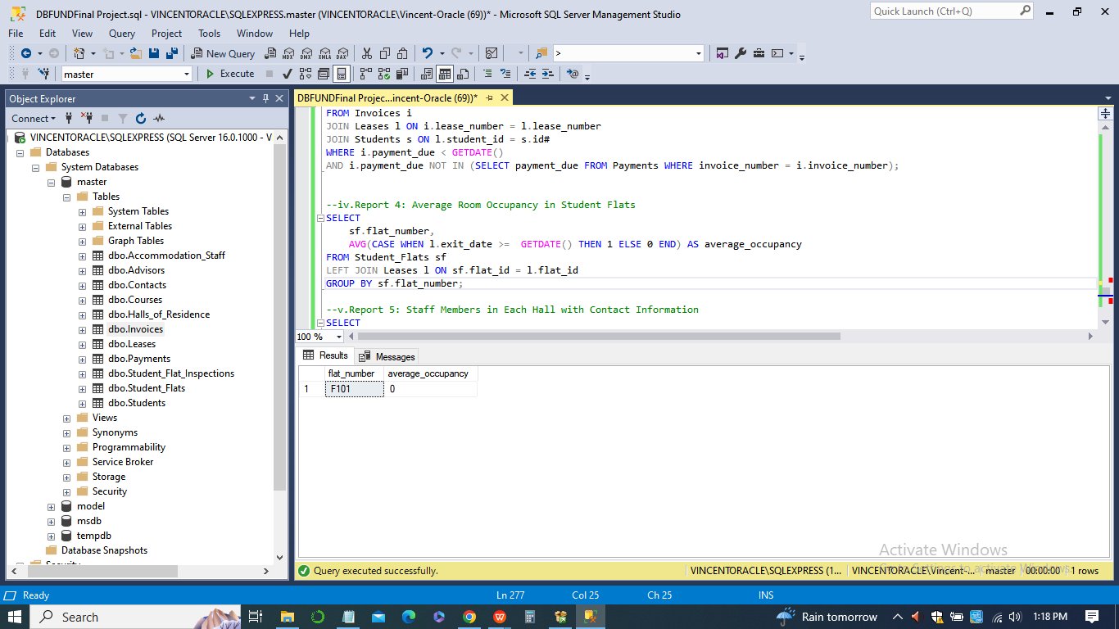

*SELECT*

*sf.flat_number,*

*AVG(CASE WHEN l.exit_date >= GETDATE() THEN 1 ELSE 0 END) AS average_occupancy*

*FROM Student_Flats sf*

*LEFT JOIN Leases l ON sf.flat_id = l.flat_id*

*GROUP BY sf.flat_number;*

1. ***Report 5: Staff Members in Each Hall with Contact Information***

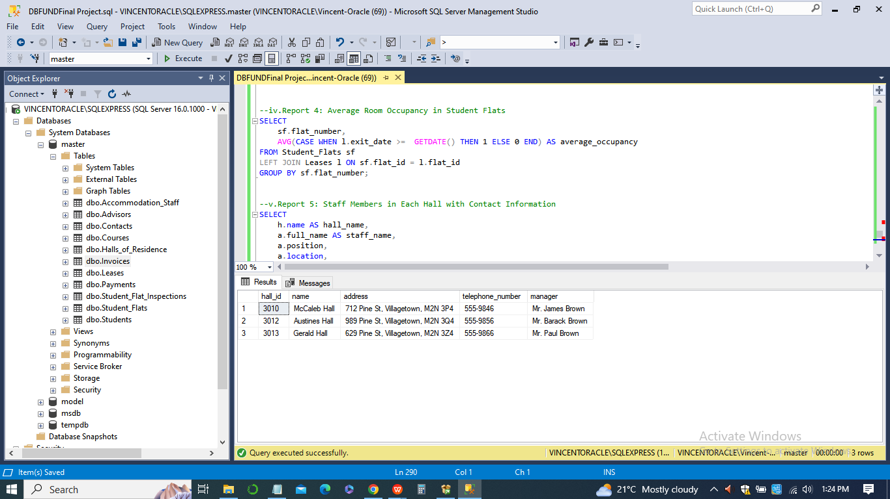

*SELECT*

*h.name AS hall_name,*

*a.full_name AS staff_name,*

*a.position,*

*a.location,*

*a.phone_number*

*FROM Halls_of_Residence h*

*JOIN Accommodation_Staff a ON h.hall_id = a.hall_id;*